

The Electric Golf Cart

Group Members:
Patrick Taylor
Andrew Bridges
Nick Paperno
David Yeung

Sponsors:
Progress Energy

Project Narrative Description:

The goal of this project is to make an energy efficient electric golf cart. The motivation of this project is based off designing a more efficient golf cart. The golf cart will have 3 different modes of operation: efficient, high performance and power saving. Efficient mode will be the standard mode of operation. The goal of efficient mode is to be a balance between high performance mode and power saving mode. The indirect relationship between power and efficiency is the reason multiple modes are necessary. In high performance mode, the golf cart is not as concerned with energy consumption. Instead, the golf cart will pull more energy to accelerate faster and have a higher top speed. Efficient mode, on the other hand, will focus on conserving energy to maximize the time until the golf cart runs out of energy. This conservation will result in a lower acceleration and a lower top speed. Power saving mode is automatically turned on when the golf cart has less than 15 percent of its charge remaining. In power saving mode, power is greatly reduced to maximize efficiency.

The electric power for the golf cart will come from batteries and a solar panel. The batteries can be charged from a wall outlet and by the solar panel. The batteries will be able to charge in a timely manner and hold their charge long enough to power the golf cart for a reasonable time and distance. There will be a simple system to test the batteries to see if one has become defective. There will be a touch screen in the golf cart that will control what mode it is in and display information. It will accurately display power usage, charge remaining, speed, estimated time remaining, temperature, etc.

Project Specifications and Requirements:

The golf cart must meet the requirements listed below in the bulletin list labeled Project Specifications and Requirements. The main idea behind the golf cart is that it must completely electrical and be a more efficient with the batteries’ charged power. Though it is a scaled down, it has the same basic concept as an electric car. From that ideology, it must be able to drive like any other car. It must have a Human Display, or HUD. With this it will show all the information coming from the sensors and the golf cart. The accuracy from the HUD must be very high. Through the HUD, the idea of the 3 modes of operations can be acted upon. There are 3 modes. First mode is normal. This will allow the golf cart to act like it normally would. The next mode is power saving mode, which allows the golf cart to use the least amount of power, and this has to be switched to when the batteries reaches 15% of their charge. The next mode is high performance mode. This mode allows the batteries to be drained at a faster rate and allow everything to run with more power. In this mode the maximum speed, which has to reach at least at 20 miles per hour, can be achieved.

Project specifications and requirements
- Must implement a power control and saving system on an electric golf cart
- Must have 4 wheels
- Must have the ability to steer and move forwards and backwards
- Must have 6, 6V flooded lead acid batteries
- Will go into a power saving mode at 15% charge remaining
- Must have a power efficiency mode with a max speed of 10 mph
- Must have a high performance mode with max acceleration possible and a top speed of at least 20 mph
- Must have a 4’by 5’ solar panel on the roof
- Must have a heads up display(HUD)
- The HUD must have a LCD display and at least 3 buttons to change into modes or have a touch screen display
- The HUD must display the charge remaining within a 3% accuracy
- The HUD must display the range remaining within a 0.5 mile accuracy
- The HUD must display the power usage of all components in the vehicle to a 3% accuracy

Milestones:
The bulleted list below is an initial proposed idea of what the project’s milestones will be. This was compiled by the amount of time left in the semester and how much work was thought would be needed to complete each task given in the milestones. Half go along with the writing of the initial research and design documentation. The other half of the milestones are what work will be needed completed on the actual physical golf cart during the spring semester. This shows what will be completely built and/or program hopefully by the end of the date specified.

Milestones
- October 18, 2010 – Table of Context completed
- October 18, 2010 – Proposal for Progress Energy completed
- November 15, 2010 – Design of HUD and Control Systems
- November 30, 2010 – Detailed design Completed
- December 2, 2010 – Report completed
- January 3, 2011 – Have a cart acquired
- January 10, 2011 – Begin building internal systems
- February 28, 2011 – Have control systems completed
- March 30, 2011 – HUD programming completed and battery & solar panels integrated
- April 30, 2011 – All systems have been integrated and working together

Electric Golf Cart Block Diagram:

Now in Figure 1.2 1, the electric golf cart block is diagram is shown. Each individual part of the block diagram has been assigned to a certain group member due to their abilities and expertise. This shows a broad view on the project as a whole. It allows the main parts to be shown. It is mainly split into two sections, which are the primary and secondary systems. The primary and secondary systems are shown in greater detail in sections, which will be discussed in a following section. Now the primary system deals with the original and main functions of the golf cart. The steering, driving, and braking will be dealt with in the primary system. Now the outputs that will come from the primary system is the speed of the golf cart, speedometer for the golf cart, odometer of the golf cart, and the if the brakes are on or off for the golf cart.

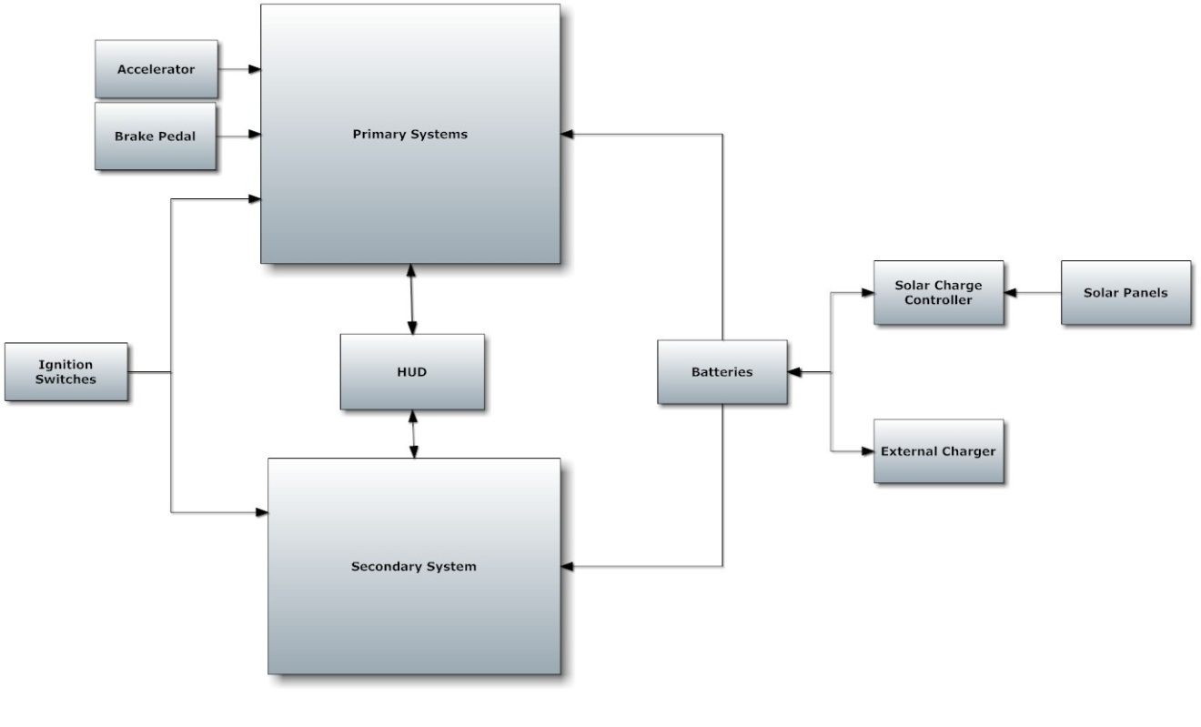
Figure 1.2 1 – Electric Golf Cart Block Diagram

Primary System Block Diagram:

In Figure 1.2 2, the basic block diagram for the primary systems is shown. Now each part will be assign to a certain group members previously done in the main block diagram that is shown above. Now the heart of the primary systems is the microcontrollers. These will be designed by the group, unless it is deemed unnecessary, or too expensive to do. Now the microcontroller will assign tasks to each other part. It directly controls the current control. The current control then controls the engine. Now the engine will indirectly affect the speedometer, odometer, and the information for the HUD. The brake pedal is already a part of any given golf cart in a minimal running conditions. The brake pedal’s information is sent to the brakes as well as to the microcontroller and then throughout the system to slow down the golf cart. The accelerator, which again should be a part of the golf cart as long as the golf cart is in minimal working condition, will send it’s information to the microcontroller, and from there it will be sent to the rest of the diagram. Now the mode controller is a major part of the primary system. It limits or removes the limits on how the golf cart can drive. The mode controller will send to the microcontroller, which of the three modes will be in use. The user will choose which of the three modes the golf cart will be running in through the HUD. From there it will then send the information to the current controller and the engine. The information will tell the engine and current controller what speed to hit and how much power can be used in the process.

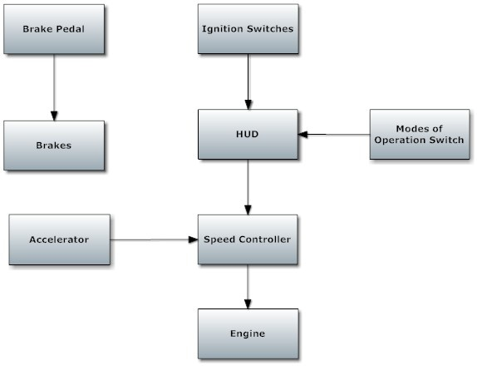
Figure 1.2 2 – Primary System Block Diagram

Secondary System Block Diagram:

In Figure 1.2 3, the secondary system’s block diagram is shown. This diagram mainly shows how the HUD operates by displaying the outputs on the screen to the user and gains the input from the users. It also shows that the HUD will deal with the lights on the golf cart. Now the display buttons will either be part of the screen, which the screen will be a touch screen at that point, or manual buttons that will be separate and run on its own controller. The display buttons’ information will be sent to the HUD and then sent to the necessary microcontrollers needed to complete the task. The display screen will get all the necessary information from the HUD. This can include but not limited to the speed of the golf cart, the distance it has gone, the charge left in the battery, and what mode the golf cart is currently in.

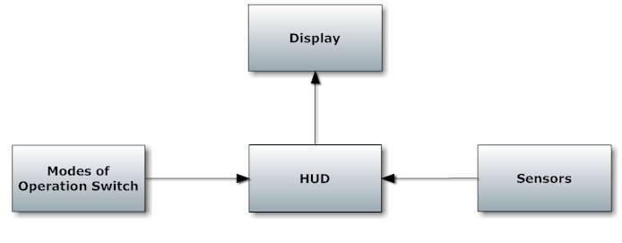
Figure 1.2 3 – Secondary System Block Diagram

Projected Budget:

The projected budget is shown in Figure 1.2 4, which can be found below. The projected budget was initially done without deep and in great detail research. Hopefully the golf will be donated to the project; however, if not a used golf will be located with a price of hopefully $600.00. That price is a bit low even for most new golf carts. The batteries originally will be at least three standard 12 Volt car battery, which can be found anywhere. The solar panel will cost around $400.00 for only one panel. If necessary to get another solar panel for the project, the funds will be redistributed. The redistributed budget will make sure that the solar panels will have enough money to meet the amount needed to complete the project’s solar section. Microchips aren’t too expensive and research shows that they can be purchased in either kits or in individual chips. Thus only $200 dollars will be projected in the budget. Now the Human interactive display is our main part that will cost a decent amount of money. The display’s budget was determined by several variables. Multiple methods were searched to see what will be the best one to use for this project to determine the budget. The sensors were estimated and will either increase or decrease due to what types of sensors and the quality of each sensor. Now in the misc. materials budget, only a $100.00 was left in it. This will be used to find any parts needed to make sure all parts will be secured onto the golf cart.

Projected Budget
Parts | Cost
Golf Cart | $600
Batteries | $300
Solar Panel | $400
Microchips | $200
Circuit Boards | $60
Misc. Material | $100
Sensors | $150
Human Interactive Display | $400
Total | $2,210
Figure 1.2 4 – Table for Projected Budget

